Lab 5 – Exploratory Analysis - Analysing the Census Income Data Set
Name: eamonn kelly
Student number = D24127620
Email address = D24127620@myTUDublin.ie
Date = 20th Oct 2026

The following is my submission for Lab 5 – Exploratory Data Analysis

Task 1 - Description of the Data
The data used was taken from Brightspace, but the reference source was also checked on UCI repository here > https://archive.ics.uci.edu/dataset/20/census+income. This provided background and variable table details.

Initial Data Preparation and Analysis
initial analysis involved visual manual inspection, opening the data files up and having a look. There is no header row /attribute names in the adult.data file, but there are in the adult .names file. We created column names based off these.
We then importing into the adult.data file into Python, and put it in a data frame. High level analysis was then performed in Python, some of the main details are included below.
Once that initial analysis was completed the data frame was exported to csv to allow import the data into Tableau. This conversion also provided attribute names for the columns and removed any leading spaces.
High level details are included below.
- # of Columns 15
- # of rows = 32,561 (# of rows in adult.data and initial dataframe)
- Number of duplicates = 24
  - Overall it was decided to keep these in and maintain original data as mcuh as possible for Tableau investigation, as data not being used for modelling, just exploration. Overall effect is negligible i.e. 24/32,561 x100 = approx. 0.07%.
- Null values present = Yes
  - “?” values were present in raw data i.e. workclass = 1,836, occupation = 1,843 and native_country = 583, total = 4,262. These “?” were converted to “null” on import.
- “unknown” / “NA” / “none” present = none
- Non-ascii characters present = None
- Column names were renamed from adult.names to what is outlined below of consistency and ease of interpretation

Feature Table

Attrib number | Attrib name | Data Type | datatyype | # of unique values | Missing Values | Description
1 | age | continuous. (Integer) | int64 | 73 | 0 | max value = 90 / min value - 17
2 | workclass | Categorical | object | 8 | 1836 | the class of work individuals perform. Working without pay and never worked are available as options, but there is no other fields available
3 | fnlwgt | continuous. (Integer) | int64 | 21648 | 0 | weighting value determined by original census data, i.e how many in people in the population the individual represents. Calculated form stat level data as per adult.names file
4 | education | Categorical (ordinal) | object | 16 | 0 | ordinal in nature as education has tiered relationship
5 | education_num | Integer | int64 | 16 | 0 | ordinal in nature as education has tiered relationship - numerical representation of education
6 | marital_status | Categorical | object | 7 | 0 | married status
7 | occupation | Categorical | object | 14 | 1843 | occupation
8 | relationship | Categorical | object | 6 | 0 | role within the household
9 | race | Categorical | object | 5 | 0 | ethnicity, 5 options and "other" is available.
10 | gender | Categorical | object | 2 | 0 | Binary value of Male or Female
11 | capital_gain | continuous. (Integer) | int64 | 119 | 0 | amount of capital gain for that year - max value of 99,999. May be erroneous data or data acquisition limit / mIn value = 0
12 | capital_loss | continuous. (Integer) | int64 | 92 | 0 | amount of losses for that year. Msx value = 4356 / Min value = 0
13 | hours_per_week | continuous. (Integer) | int64 | 94 | 0 | hours worked per week .. Max value = 99 / lowest value = 1
14 | native_country | Categorical | object | 41 | 583 | country of origin, 41 unique values recorded.
15 | income_bracket |  | object | 2 | 0 | income of individual - Target label in predictive model. Boolean in nature, i.e. <=$50K or > 50K

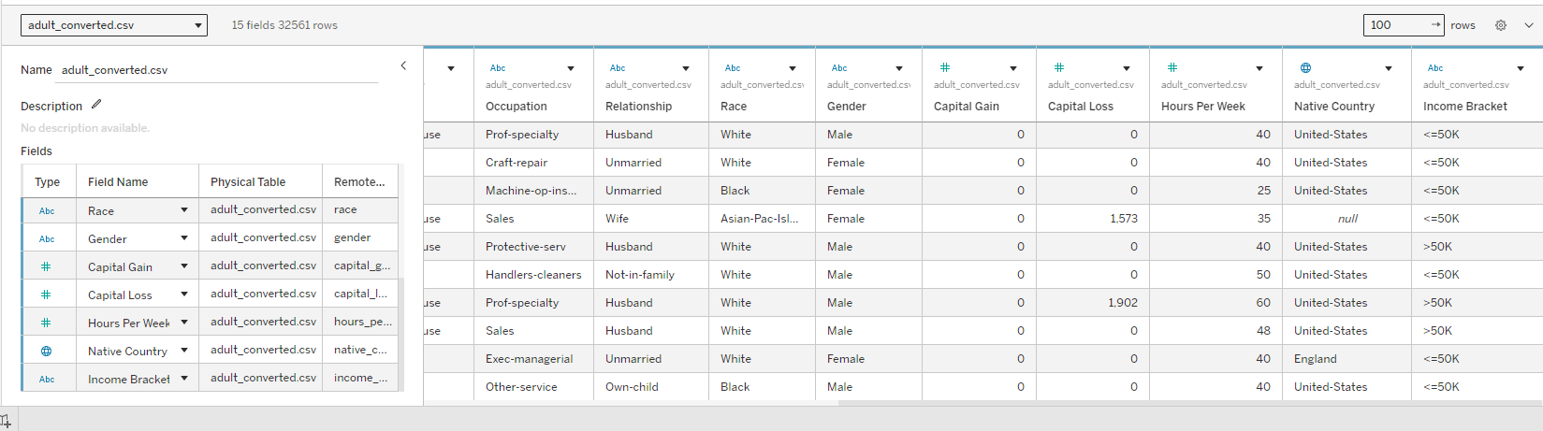

Task 2 - Create visualisations for each of the features in the dataset to explore the data in terms of fairness and completion.

Feature visualisations
The following are individual plots per feature to get a sense of the data and its distribution and any gaps.

Age

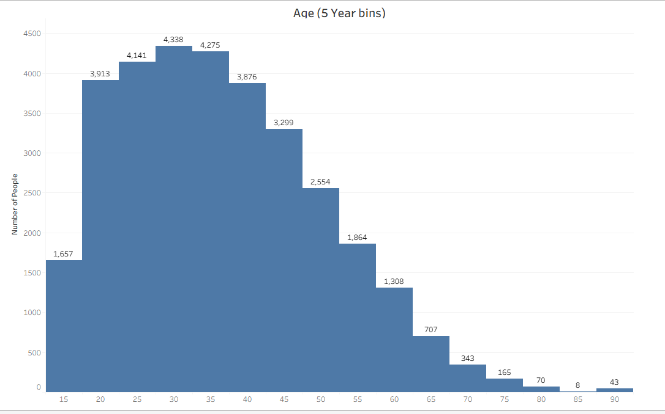

Note:
- The age distribution is not quite normal, rather bell shaped and right (or positively) skewed, with most record occurring between 20 and 50, with a long tail stretching out to older ages. The mean age is 38.58 years. The first bar has no values < 17, so only has ages from 17 up, despite the bin being in values of 5.
- The 90 age bar(43 people) is bigger than the previous 85 age bar (8), which is unusual.
- Plot is available on public tableau here > https://public.tableau.com/app/profile/eamonn.kelly1417/viz/Lab5ExploratoryAnalysis-Age/Age?publish=yes

Workclass

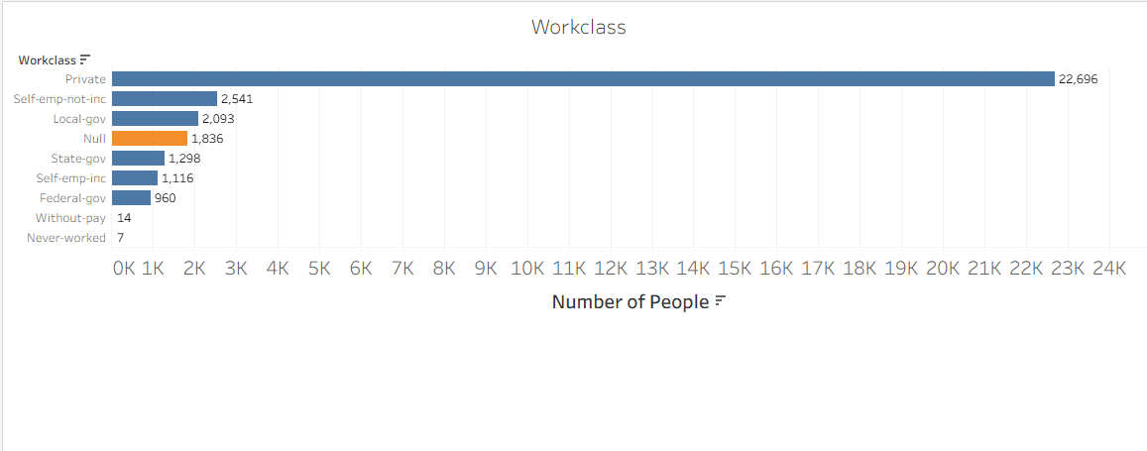

- Note:
- Largest class of working is private. With 1836 not entering any value or is missing data. “never-worked” and working “without-pay” are at 7 and 14 respectively.
- Plot is available on public tableau here > https://public.tableau.com/app/profile/eamonn.kelly1417/viz/Lab5ExploratoryAnalysis-Workclass/Workclass?publish=yes

Final Weight

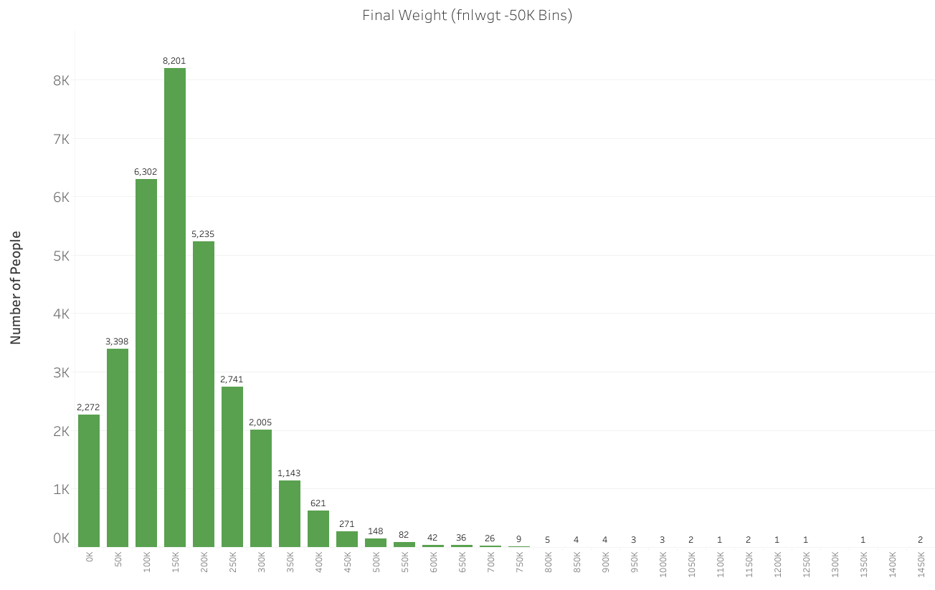

- Note:
- After trial and error, we ended up using 50K bin sizes. There are no missing values. The mean value was 1.897784e+05. There is an elongated tail and the plot is right skewed. There is also kurtosis with a long tail , it is leptokurtic.
- Each count value does not represent an equal share of the population, so it appears to be different to general census data.
- Plot is available on public tableau here > https://public.tableau.com/app/profile/eamonn.kelly1417/viz/Lab5ExploratoryAnalysis-FinalWeight/FinalWeightfnlwgt?publish=yes

Education

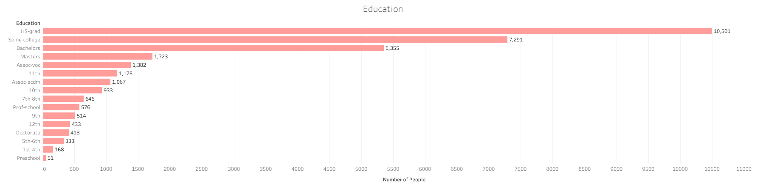
- Note:
- There are no missing values and 16 categories.
- The order is not by order of education level in the plot, rather sorted by count. The High School graduate being the largest with approx.. 32%, “some-college” and then “Bachelors” being 2nd and 3rd.
- The pre-school value as the highest level of education appears at first glance to indicate the individual never progressed through school, however it could include immigrants who never completed school abroad, or work in low paid manual jobs. This would eb a valid population segment.
- Relationship with native country will be an interesting relationship to see to potentially verify this. Also earnings <= 50K for this category would require care with the model training as would eb a small sample size at 51.
- Plot is available on public tableau here > https://public.tableau.com/app/profile/eamonn.kelly1417/viz/Lab5ExploratoryAnalysis-Education/Education?publish=yes

Education Num

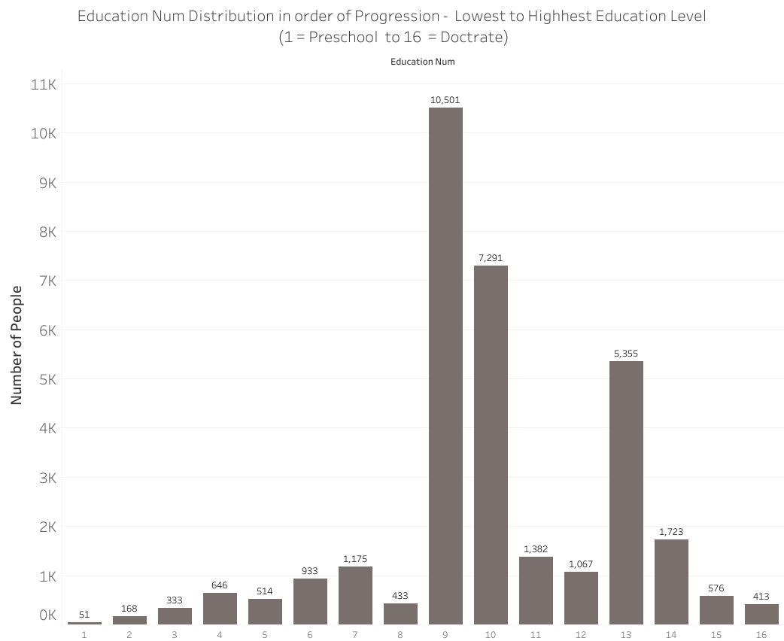

- Note:
- Numeric code for education level, which is ordinal in nature. There are no missing values.
- Plotted here in numerical order of progression.
- Plot is available on public tableau here > https://public.tableau.com/app/profile/eamonn.kelly1417/viz/Lab5ExploratoryAnalysis-EducationNum/EducationNum?publish=yes

Marital Status

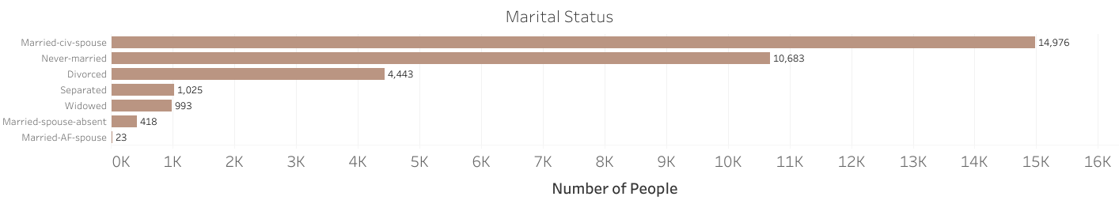

- Note:
- Two Categories make up the majority of the categories.
- Some clear distinctions would need to be clarified in relation to married categories, i.e. Married-AF-Spouse and Married-spouse-absent, “AF refers to armed forces apparently. Also no reference to same sex marriage, so category may not be represented.
- Cohabiting / civil partnerships are not represented either.
- Plot is available on public tableau here > https://public.tableau.com/app/profile/eamonn.kelly1417/viz/Lab5ExploratoryAnalysis-MaritalStatus/MaitalStatus?publish=yes

Occupation

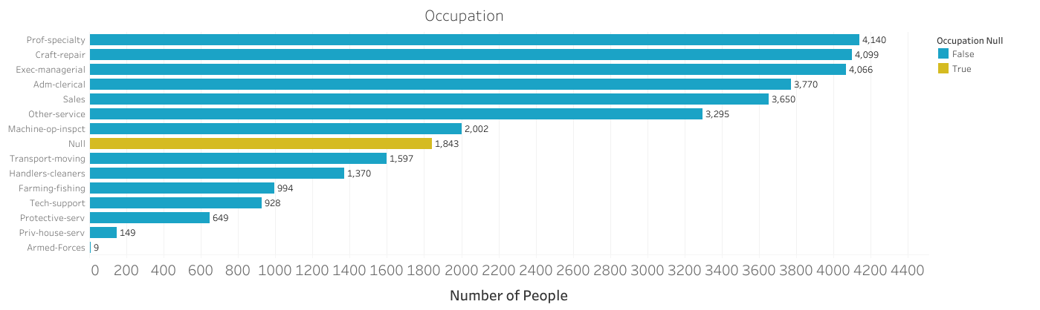

- Note:
- Null values present in the data, 1,843 missing values. Related to workclass although data is less skewed than workclass.
- Relationship between occupation and gender may also show a correlation for some professions.
- Plot is available on public tableau here > https://public.tableau.com/app/profile/eamonn.kelly1417/viz/Lab5ExploratoryAnalysis-Occupation/Occupation?publish=yes

Relationship

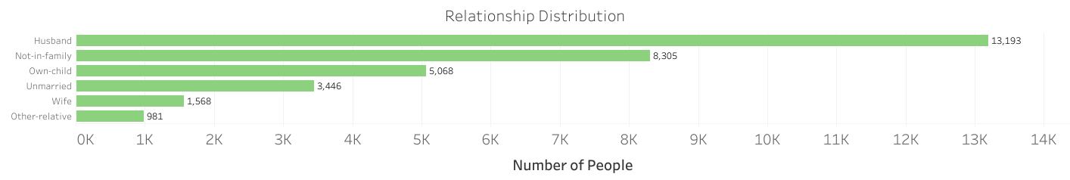

- Note:
- Category relates to each person’s role in ther household
- Husband = 13,193, wife = 1,568 which seems to be a big gap. Would expect relatively even numbers across gender. Given the data is taken from 1994, ti may be related to women not working and staying at home and perhaps being cleaned out.
- Relationship between occupation and gender may also show a correlation for some professions.
Relationship | Female | Male
Husband | 1 | 13192
Not-in-family | 3875 | 4430
Other-relative | 430 | 551
Own-child | 2245 | 2823
Unmarried | 2654 | 792
Wife | 1566 | 2
  - 1 Female classed as “Husband” and 2 Males classed as “Wife”. Most likely data entry error.
- Plot is available on public tableau here > https://public.tableau.com/app/profile/eamonn.kelly1417/viz/Lab5ExploratoryAnalysis-Relationship/Relationship?publish=yes

Race

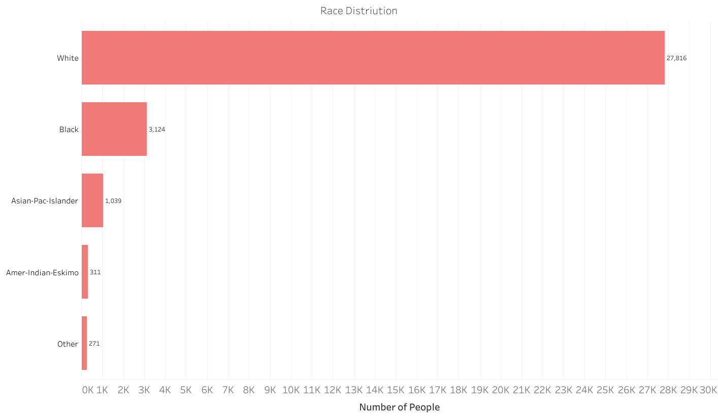

- Note:
- There are no missing values but data has a large skew with “White” group being > 27K of data i.e. approx. 85%.
- Some populations aggregated i.e. Asian, Hispanic, Latino, i.e. very broad categories and could lead to misclassification.
- Model trained on this data will have bias in relation to training data being heavily skewed to category “white”
- Plot is available on public tableau here > https://public.tableau.com/app/profile/eamonn.kelly1417/viz/Lab5ExploratoryAnalysis-Race/Race?publish=yes

Gender

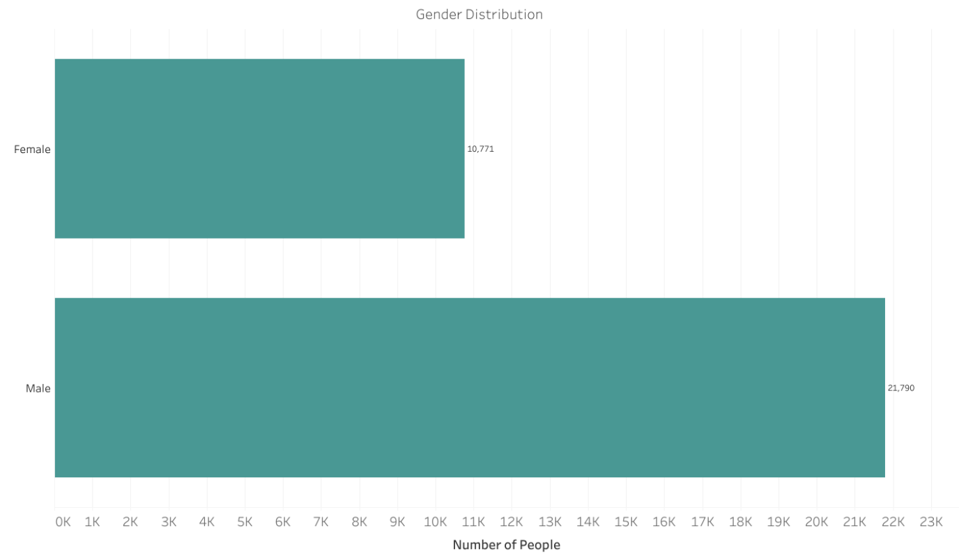

- Note:
- Men outnumber women by approx. 2 to 1 i.e. approx. 66% men approx. 33% women. Ral population sample would be approximately 50/50 split. This may be due to cleaning of the data and working or earning status.
- Doesn’t take account of anyone who identifies are neither male nor female.
- Plot is available on public tableau here > https://public.tableau.com/app/profile/eamonn.kelly1417/viz/Lab5ExploratoryAnalysis-Gender/Gender?publish=yes

11) Capital Gain

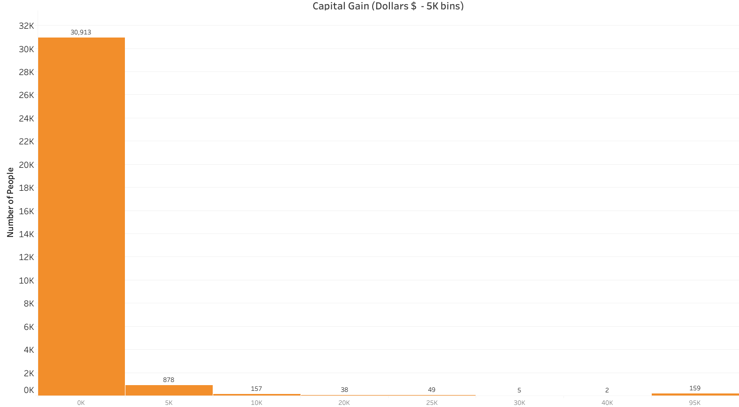

- Note:
- There are no missing values but the data has a very large skew, and very long tail.
- 91% of people have 0 capital gain, and 159 individuals have exactly 99,999 as their capital gain amount. May be a data collection limit value. All of those earn > $50K
- This relates to the number of people with values of “99,999” and also at “0”
- Plot is available on public tableau here > https://public.tableau.com/app/profile/eamonn.kelly1417/viz/Lab5ExploratoryAnalysis-CapitalGain/CapitalGain?publish=yes

Capital Loss

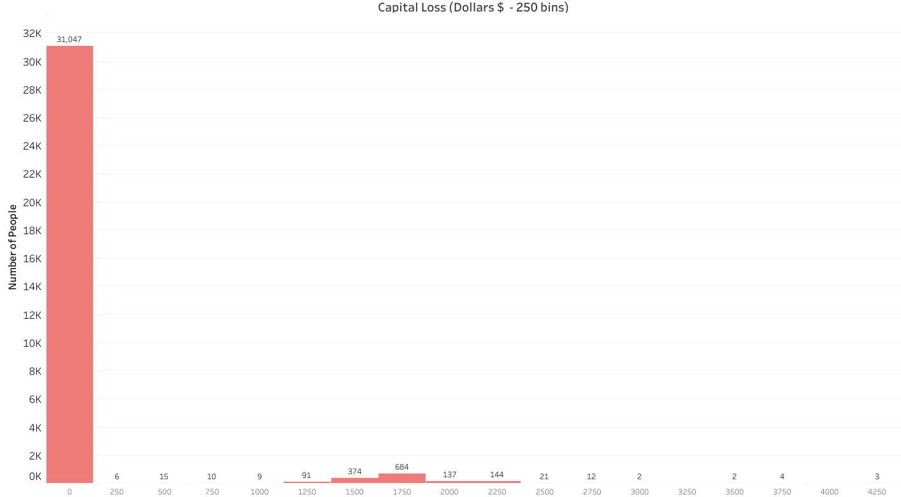

- Note:
- There are no missing values but the data has a very large skew, and very long tail, as per Capital Gain
- Maximum value of $4,356 and min at zero, with 95.3 % of population are “0”
- No one has a gain and a loss, which is good validation
- A non-zero value would indicate the individual has money invest and possibly lose.
- Plot is available on public tableau here > https://public.tableau.com/app/profile/eamonn.kelly1417/viz/Lab5ExploratoryAnalysis-CapitalLoss/CapitalLoss?publish=yes

13) Hours per week

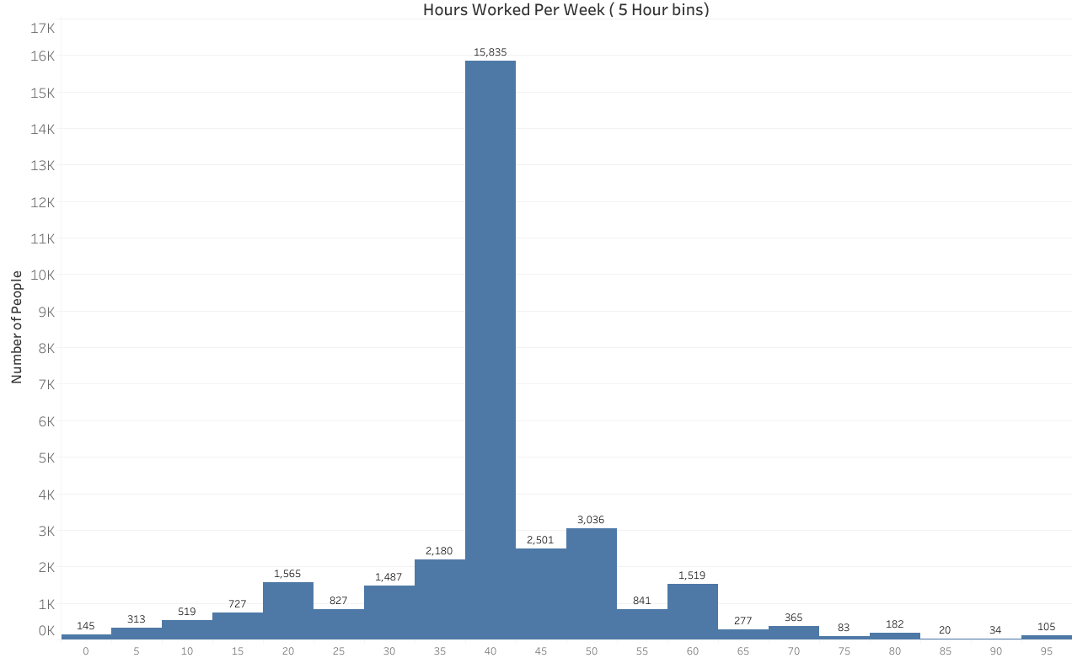

- Note:
- There are no missing values and the data is relatively symmetric, but extremely peaked.
- 15,835 individuals work between 40 and 44 hours per week.
- Max value - 99 and min value = 1, indicates these caps may represent people who may have zero hours a week or greater than 99. Those with zero hours work are not represented, or represented in the 1 value, these individuals appear to be largely excluded.
- Plot is available on public tableau here > https://public.tableau.com/app/profile/eamonn.kelly1417/viz/Lab5ExploratoryAnalysis-HoursperWeek/HoursperWeek?publish=yes

Native Country

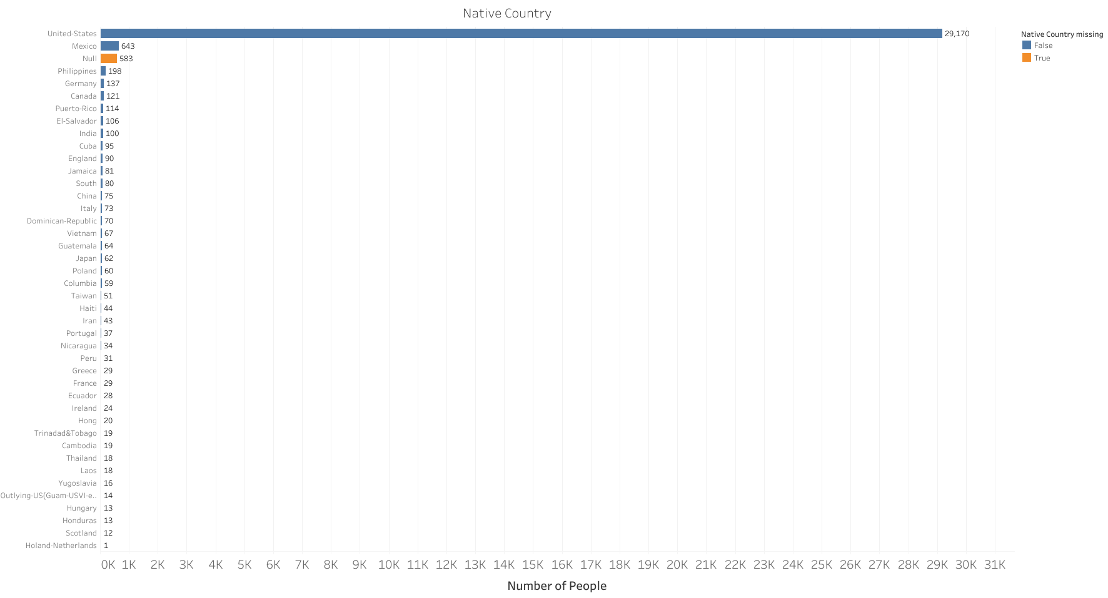

- Note:
- Has 583 missing values. Data is heavily skewed, and > 89% are United States. Mexico is the only other country with > 200 values.
- Plot is available on public tableau here > https://public.tableau.com/app/profile/eamonn.kelly1417/viz/Lab5ExploratoryAnalysis-NativeContry/NativeCountry?publish=yes

Income Bracket

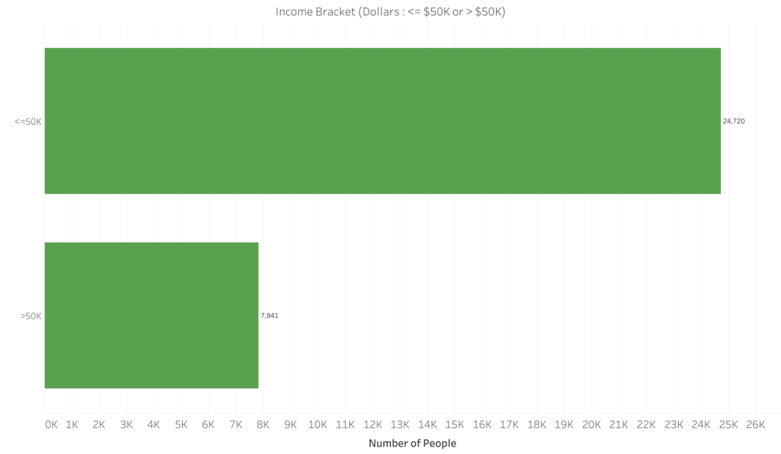

- Note:
- <=$50K (approx. 75%) is approximately 3 times more common than >$50K (24%). This would be a class imbalance to be aware of when training any model.
- As bands are fairly rudimentary, ie.. only two of then, individuals on the edge either side of the cut off can appear the same as someone twice more or twice less than their income.
- Plot is available on public tableau here > https://public.tableau.com/app/profile/eamonn.kelly1417/viz/Lab5ExploratoryAnalysis-IncomeBracket/IncomeBracket?publish=yes

Fairness and Completion
The following are more targeted visualisations of specific data in terms of fairness and completion, based off initial findings. In the earlier sections.

Income bracket vs Gender

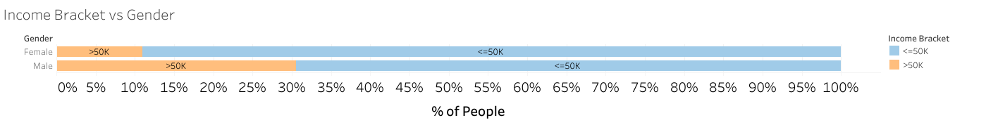

- Visualisation shows 30.57% of men earn >50K and 10.95% of women earn >$50K.
- Any model trained no this data would infer that gender is a predictor of income.
- Plot is available on public tableau here
https://public.tableau.com/app/profile/eamonn.kelly1417/viz/Lab5ExploratoryAnalysis-IncomeBracketvsGender/IncomeBracketvsGender?publish=yes

Income bracket vs Race

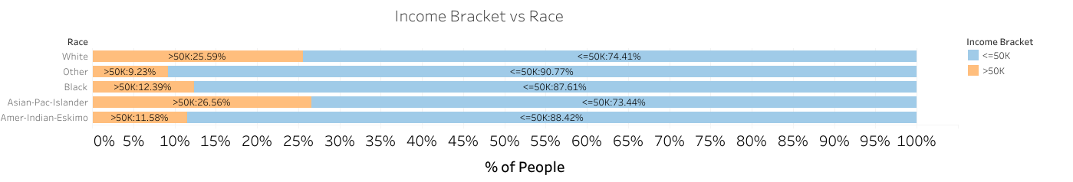

- Visualisation shows Asian-Pac-Islander at 26.6% and White at 25.6% with income > $50K. Values for other Races are significantly smaller.
- Any model would find much stringer data in those two elements. The Asian-Pac-Islander is a very broad category also, with white also being very broad and would include people from European backgrounds. More stratification of race would help accuracy of any model
- Plot is available on public tableau here
https://public.tableau.com/app/profile/eamonn.kelly1417/viz/Lab5ExploratoryAnalysis-IncomeBracketvsRace/IncomeBracketvsRace?publish=yes

Education Level Attained per Native Country

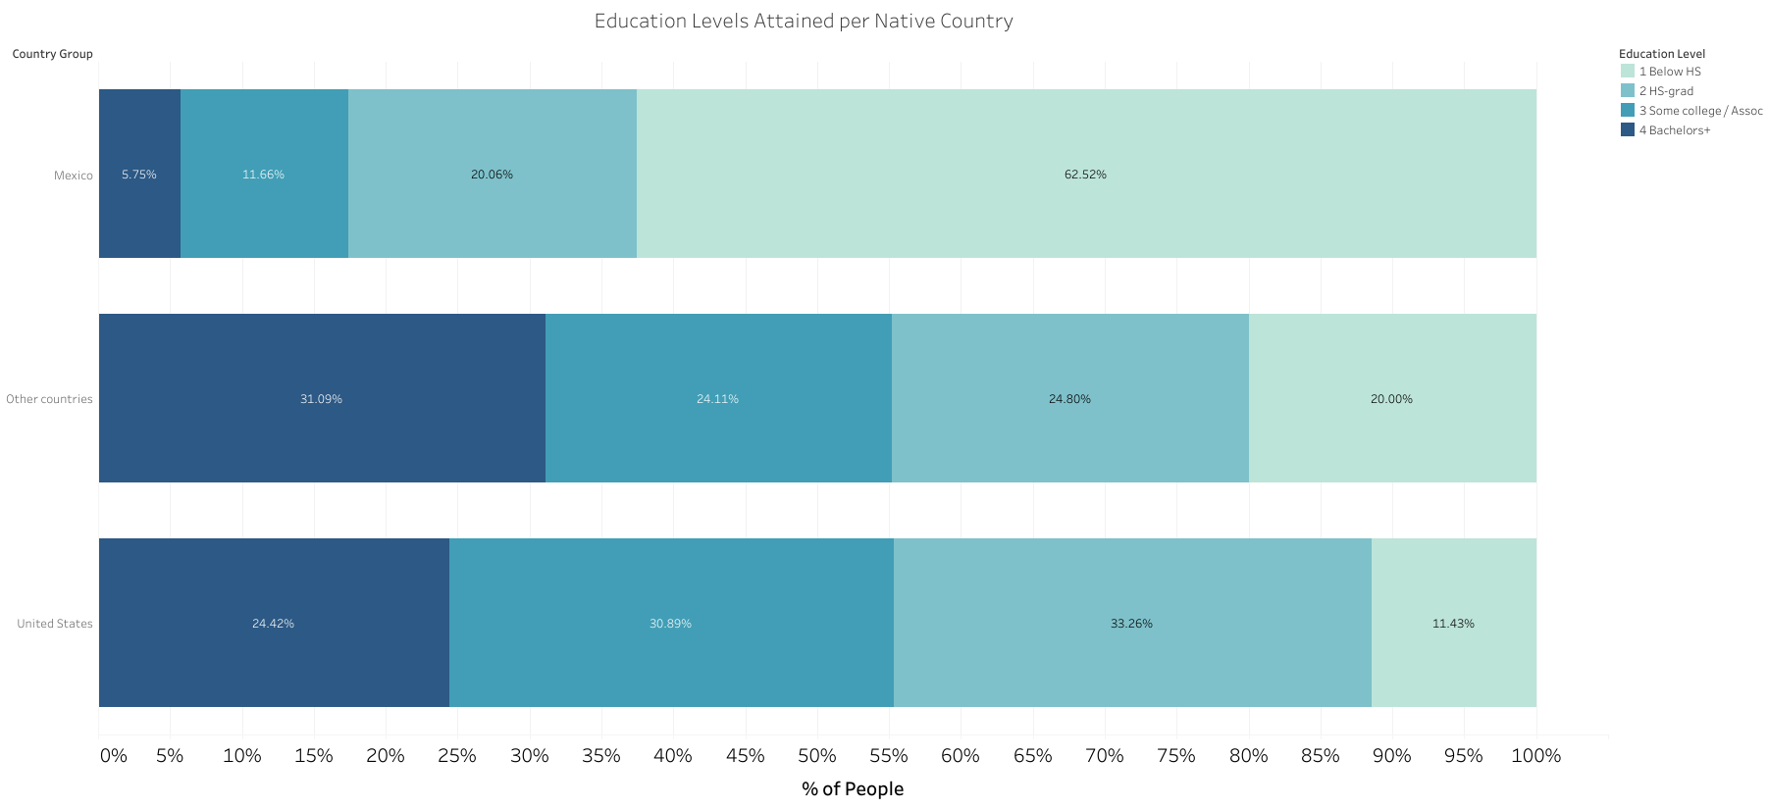

- Aggregated countries into “United States”, “Mexico” and “Others countries”, to make visualisation readable.
- Education was also aggregated into 4 tiers, “Below HS”, “HS-grad”, “Some College” and “Bachelors+” to make it readable
- Mexico has the highest number below High School level at approx. 62.5%, and also the lowest number of “Bachelors+” at approx. 5%
- Any model using this would use native country as a strong predictor or education. However, most countries have small sample sizes, so may not be a fair reflection of the state of education in that country
- Plot is available on public tableau here
https://public.tableau.com/app/profile/eamonn.kelly1417/viz/Lab5ExploratoryAnalysis-EducationvsCountry/EducationbyCountry?publish=yes

Questions

- Q: Are there missing feature values for a large number of observations?
A: The following features are missing values
- Woskclass = 1,836
- Occupation =1,843
- Native country = 583

- Q: Are there features that are missing that might affect other features?
A: Yes, there is overlap in terms of features and missing values. “Occupation” and “workclass” are directly related features, and the all “workclass” values are missing alongside the ”occupation” values. As a result analysis of “occupation” will also have the missing data from “workclass” also as a factor.

- Q: Are there any unexpected feature values?
A: Yes, as below
Age: there are more individuals in aged 90 category than in the 85 to 89 category
Relationship: 1 “Female” is listed as a “Husband” and 2 “Males” are listed as a “Wife”.
Education: A significant number of individuals never attained education level higher than pre-school, probably means received n formal schooling.
Marital Status: There is very little diversification in terms of marriage data.

- Q: What signs of data skew do you see?
A: The following features show signs of skew
- Workclass: Right skewed with elongated tail.
- Occupation: skewness less than “workclass” btu none the less still present.
- Race: is heavily skewed with “White“ group being very dominant.
- Capital Gain: heavily right skewed and long tail with 91% of people with “0” capital gain.
- Capital Loss: heavy right skew again, with approx. 95% of population with a “0” value.
- Native Country: heavily skewed with 89% from “Unites States”

Task 3 Answer the following questions

Question 1
Q: How would you describe the relationship between education level and income bracket?
Answer:
Visualisation: Income Bracket vs Education
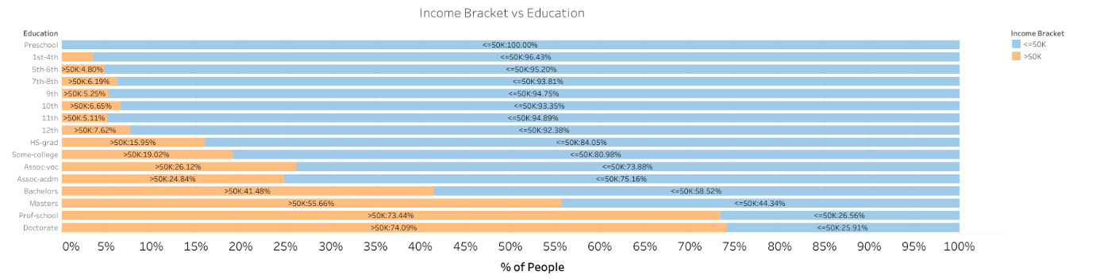

- Theres a string positive relationship between income bracket and education level. The higher the education level attained the greater the proportion of individuals earning > $50K
- It is not a linear relationship, more similar to an exponential relationship from the values we have.
- Visualisation available on Tableau public here https://public.tableau.com/app/profile/eamonn.kelly1417/viz/Lab5ExploratoryAnalysis-IncomeBracketvsEducation/IncomeBracketvsEducation?publish=yes

Question 2
2. What noteworthy observations can you make about the gender distributions for each marital-status category?
Answer:
Visualisation: Gender vs Marital Status

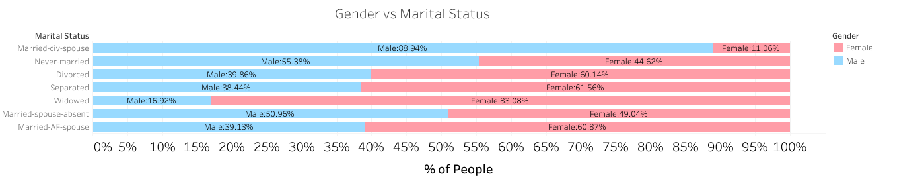

- “Married-civ-spouse “ is the largest category for Male, over 88% male and only 11% female. This is an unexpected result. Probably caused by data cleaning and removal of low wage low hour working or original data source. Would need a bti more investigation however.
- Widowed has a greater proportion of females at 83% and Females in general are the majority in categories where no spouse is present.
- Marital status and gender and relationship are related in the dataset. Married women not working do not appear to be present. This would result in bias in the training of any model
- Visualisation available on Tableau public here https://public.tableau.com/app/profile/eamonn.kelly1417/viz/Lab5ExploratoryAnalysis-GendervsMaritalStatus/GendervsMaritalStatus?publish=yes

